Appointing Unpaid Visiting Scholars via Courtesy Express

This guide will detail the steps to appoint Unpaid Visiting Scholar candidates via Courtesy Express in OMNI HR. Collaborating and connecting with a diverse group of scholars is vital to advancing the research and education missions of the University. Visiting Scholars may come to Florida State University at the invitation of an FSU faculty or staff member working in their field.

Visiting Scholars work collaboratively with faculty or staff members in areas of research and creative activity. These activities should:
- Be of mutual benefit to the scholar and FSU
- Keep faculty abreast of worldwide innovations
- Build linkages for further research collaboration
- Enhance the reach and recognition of the University and its programs
- Expose FSU students to other cultures and different approaches to common challenges

NOTE: Researchers and Postdocs employed by FAMU through the College of Engineering are exempt from the Visiting Scholar Process.

Each semester, the Office of Human Resources creates a non-advertised job opening for use by the entire University, known as the Courtesy Express. This process is used after the Unpaid Visiting Scholar process has been completed in RAMP and approved. The Courtesy Express job opening will display for departments in the Recruiting > Search Job Openings list, but it is not advertised as a job for which applicants can apply. The department creates the applicant record, links the record to the current Courtesy Express pool, and prepares the job offer.

Key Information:
- Required Roles: FSU_SS_MANAGER and FSU_ERS_ADD_EXPRESS
- Courtesy SupplementalDocs
- Courtesy Job Codes
- J-1 Visas
- Unpaid Visiting Scholar Guidelines
- Unpaid Visiting Scholar Policy

Unpaid Visiting Scholar and J-1 Visa

STEP 1: Complete the Visiting Scholar Request Process in the Export Control Portal.

NOTE: Download a copy of the completed Export Control Confirmation to upload in the job offer later.

STEP 2: If necessary, complete any and all J-1 application documents and send them to the Center for Global Engagement.

NOTE: Do not submit a job offer until all requirements for the Unpaid Visiting Scholar Process and J- 1 application have been completed and approved.

Confirm the Candidate’s FSU Affiliation

STEP 3: Prior to creating the appointment record, ask the hiring manager if the candidate is new to FSU or if they have an affiliation with FSU (i.e., are they a current employee, former employee, or current/former student):
- If the candidate is a current employee, former employee, or current/former student, ask them to provide you with their Empl ID/Student ID and FSUID for the purpose of the department creating the appointment record.
  - The candidate can find this information by logging into the myFSU portal and referring to
the section under “Welcome” in the upper right of the page.
  - Never ask for a candidate’s password.
  - Obtain a valid email address from the candidate.
- If the candidate is not affiliated with FSU, or is affiliated, but does not know their FSUID and Empl ID/Student ID, proceed with adding them as a candidate new to FSU.
  - Obtain a valid email address from the candidate.

STEP 4: Log into myFSU > click on the HR icon.

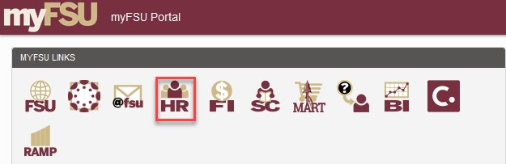

Appointing the Visiting Scholar via Courtesy Express
STEP 5: Click the Recruiting tile.

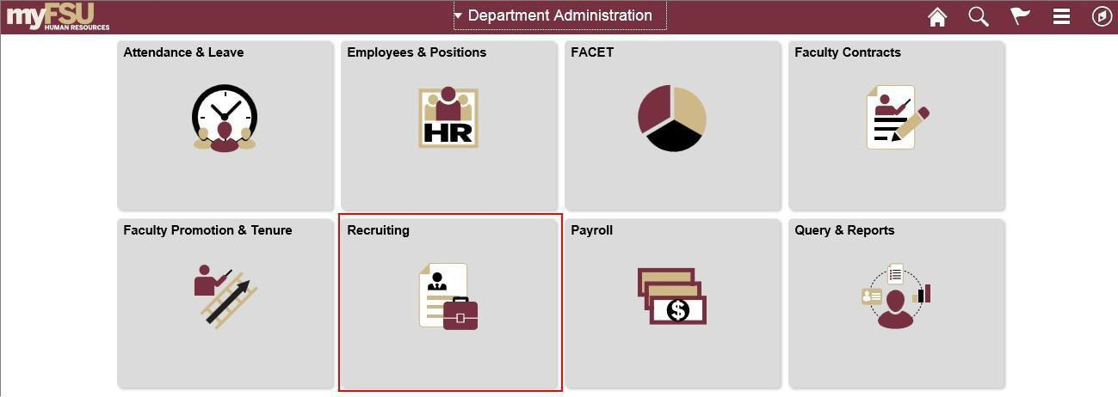

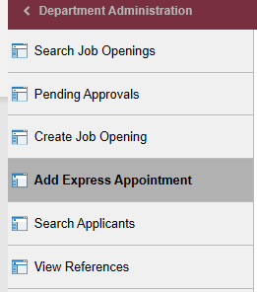

Adding CANDIDATES NEW TO FSU
STEP 6a: On the Express Appt page:
- Allow Applicant Type to default to “Express Appt”.
- Enter the candidate's legal name in the First Name and Last Name fields.
- Click Add Email Address > choose email type > enter a valid email address > click Save or
Save and Create Another to create additional express appointments.
Note: The email provided is where the Smart Onboarding invitation will be sent later in the process. For email type, please only use “Other” or “Home” – inserting a “Campus” or “Business” email type will result in the candidate not receiving the “Activate your FSUID” email.
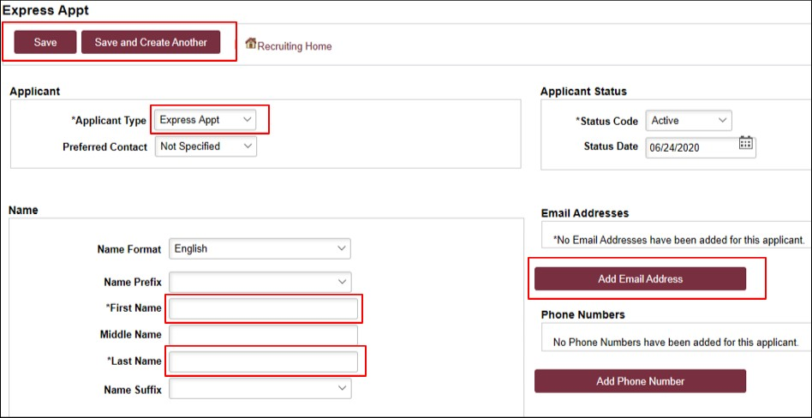

- Note the Applicant ID that generates and proceed to step 7.
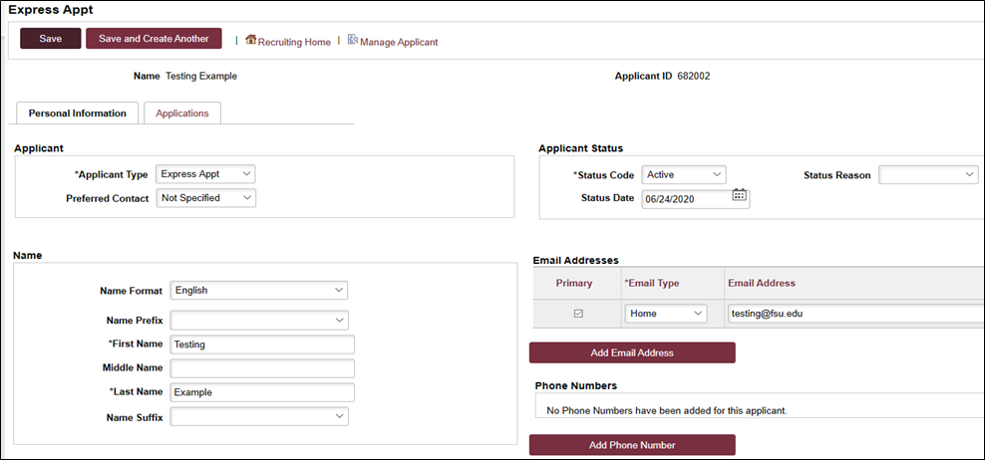

Adding EMPLOYEES, REHIRES, and CURRENT & FORMER FSU STUDENTS
IMPORTANT! Completing the steps below will sync the onboarding invitation with the candidate’s myFSU account; therefore, it is very important that you have confirmed their affiliation. If in doubt, enter as an Express Appt versus an Employee.
STEP 6b: If the candidate is a current employee, former employee, or current/former student, and has provided their Empl ID/Student ID and FSUID, take the following steps:
On the Express Appt page:
  - Choose Employee from the Applicant Type dropdown menu > click Search.
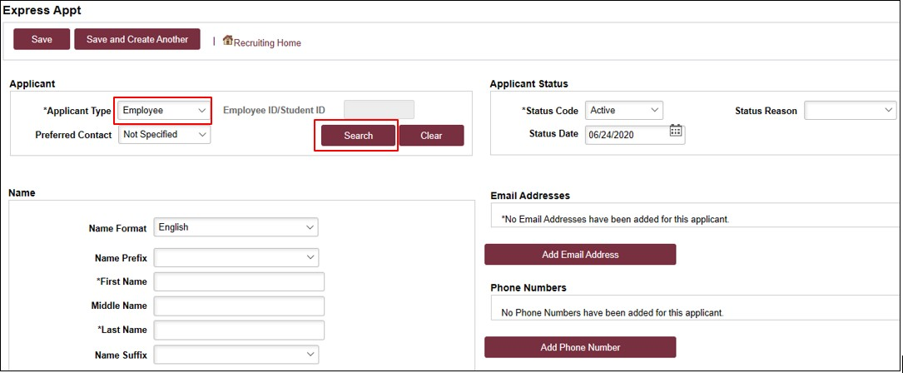
- On the search page, enter the candidate’s Empl ID/Student ID in the Empl ID/Student ID
field and FSUID in ALL CAPS in the User ID field > click Search.
- When you have confirmed a match, click Select to continue adding the record.
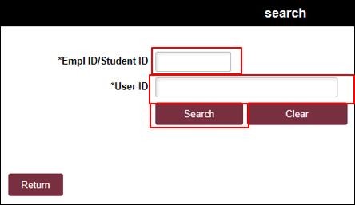

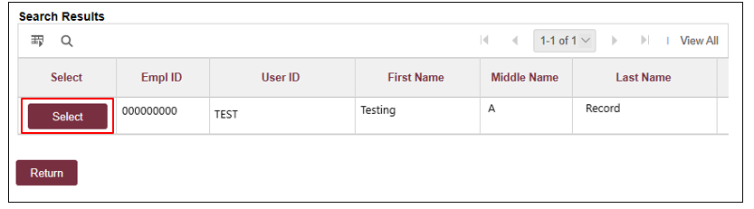
- The legal name and last known email address will populate on the page. Update the email address if needed.
- Click Save, or Save and Create Another to add additional express appointments.
- Note the Applicant ID that generates and proceed to step 7.
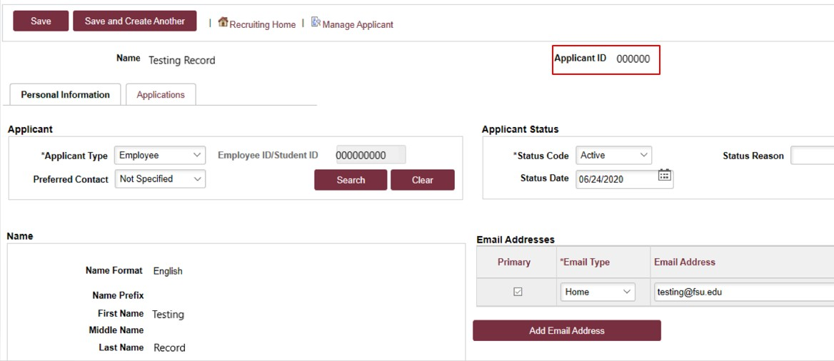
Notes:
- The email address provided is where the Smart Onboarding invitation will be sent later on in the process. If the appointment is created with an Empl ID/Student ID, it will carry over to the job offer. When the Onboarding invitation is launched, the candidate will be directed to log in at the myFSU portal to complete onboarding.

Linking the Record to the Courtesy Express Pool
STEP 7: Navigate to Recruiting > Search Applicants > enter the applicant ID in the Applicant ID field > click
Search.
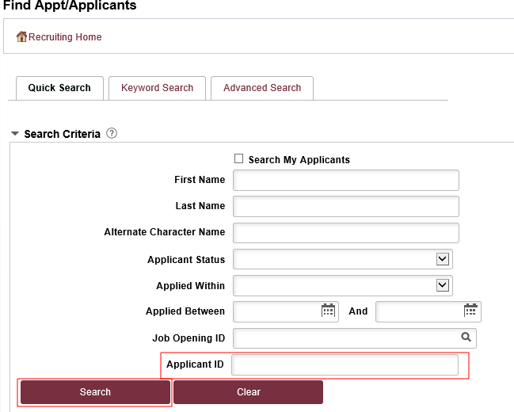

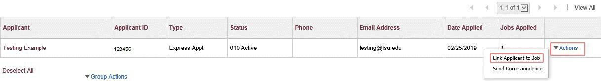
STEP 8: Across from the candidate's name, use the Actions drop-down menu to select Link Applicant to Job.

STEP 9: Enter or select the correct semester’s Courtesy Express job ID in the Job Opening ID field > click
Link.

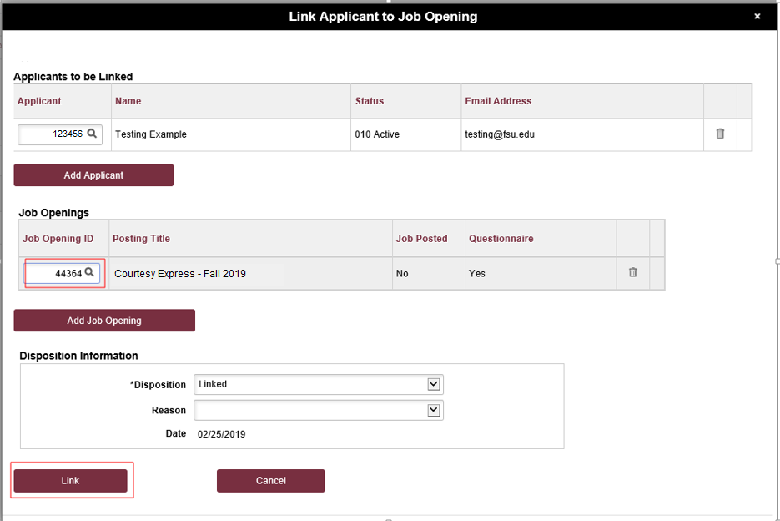

Preparing the Job Offer
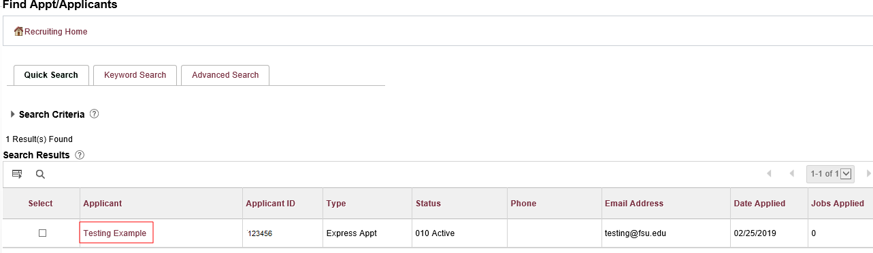
STEP 10: After the applicant’s record has been successfully linked, click on the candidate's name to be redirected to the job opening(s) associated with the applicant’s ID.

STEP 11: Under the appropriate Job Opening, click on Other Actions.

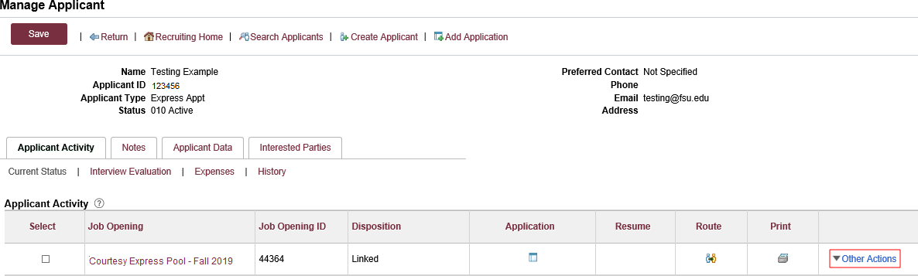

STEP 12: Click Recruiting Actions > Prepare/View Job Offer.
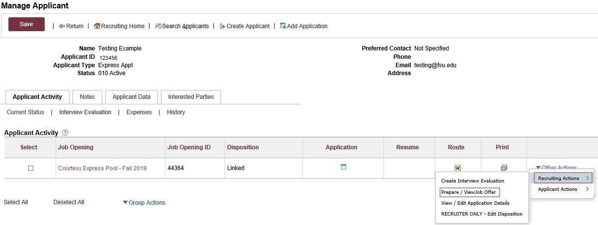
STEP 13: Begin on the Offer Details tab.

STEP 14: Navigate to the Comments section. Enter information pertaining to the candidate and/or job offer, such as employee ID, type of appointment (new, rehire, additional appointment), description of duties, and that the appointment is an Unpaid Visiting Scholar. If the appointment is a Post Doc, please include financial support information including the source and amount of funding.

The Post Doc job code is only appropriate if it meets the minimum requirement for salary per the Office of Postdoctoral Affairs. Courtesy Post Docs are paid through an external grant or their home university.

STEP 15: Navigate to the FSU Offer – Additional Info section.
Enter the appropriate Job Code or click the look up button to select the appropriate Courtesy Job Code. To determine the appropriate Courtesy job code, review the information here.

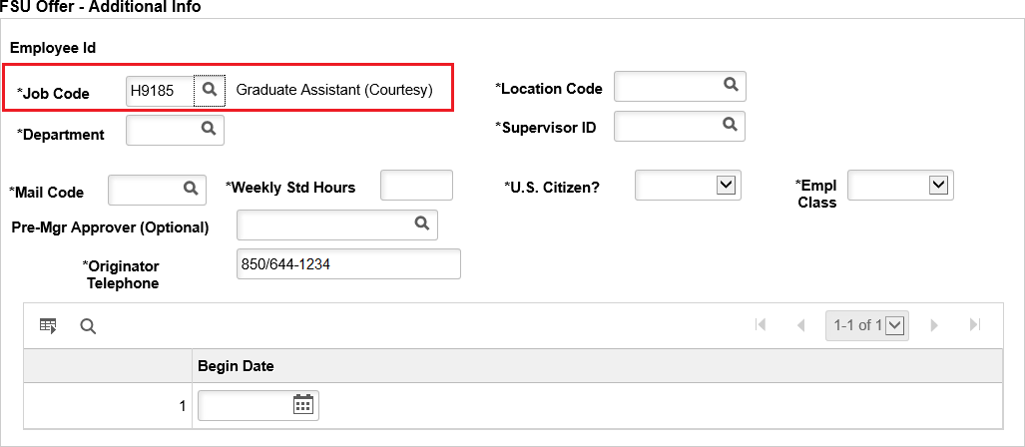
Note: The default code COUX is not a valid job code.

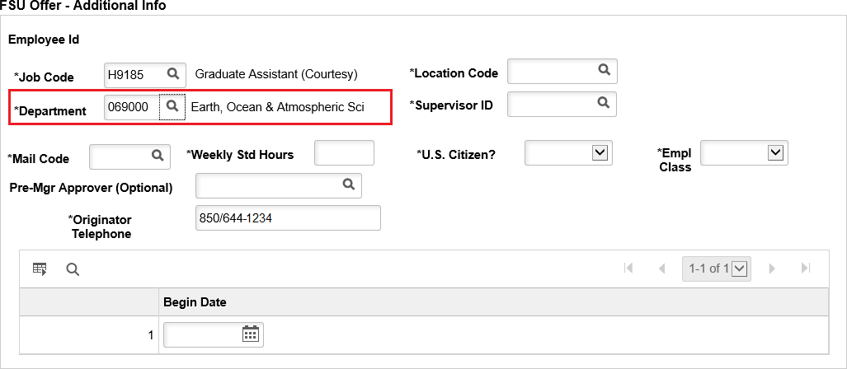
STEP 16: Enter the appropriate Department or use the lookup button to search and select the desired Department.

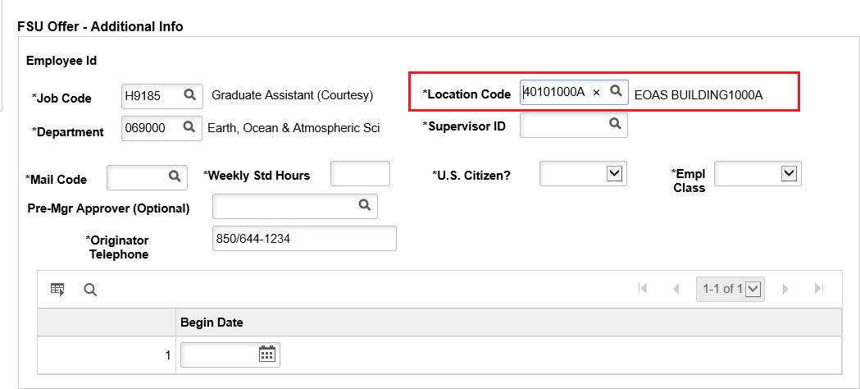
STEP 17: Enter the appropriate Location Code or use the lookup button to search and select the desired Location Code.

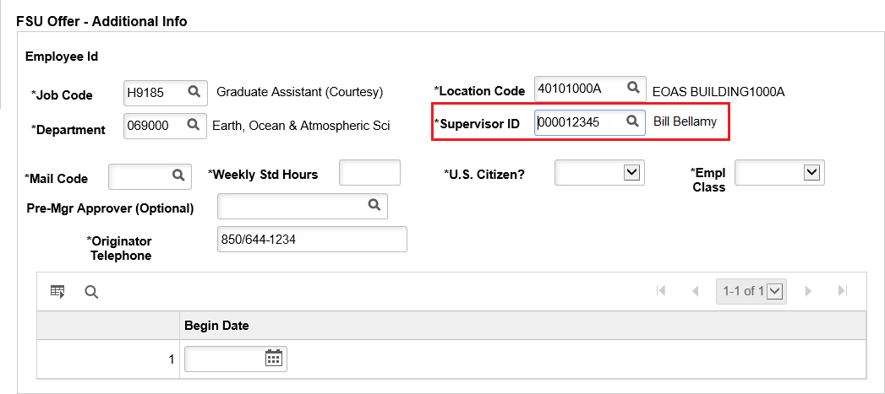
STEP 18: Enter the appropriate Supervisor ID or use the lookup icon to search for the desired Supervisor ID.

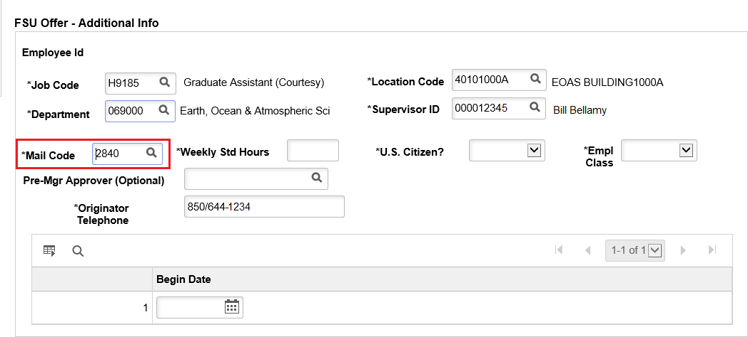
STEP 19: Enter the appropriate Mail Code or use the lookup icon to search for the desired Mail Code.

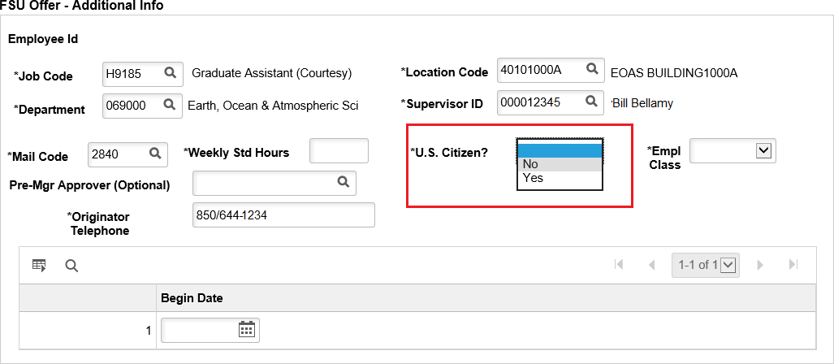
STEP 20: Click the U.S. Citizen? drop-down menu. Select the appropriate answer from the list.

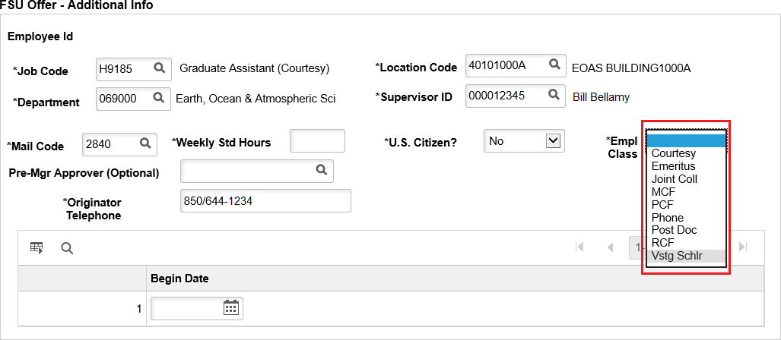
STEP 21: Click the Empl Class drop-down menu. Select the appropriate classification. "Vstg Schlr" should be used for Unpaid Visiting Scholars.

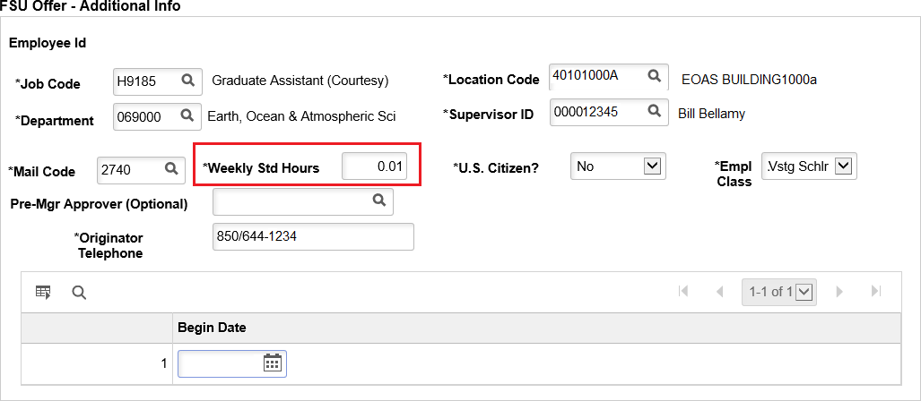
STEP 22: Enter the appropriate weekly standard hours. Most visiting scholar appointments will have a 0.01 standard hours entry.

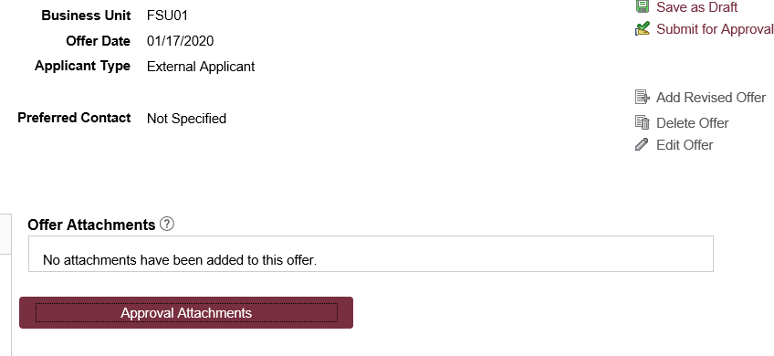
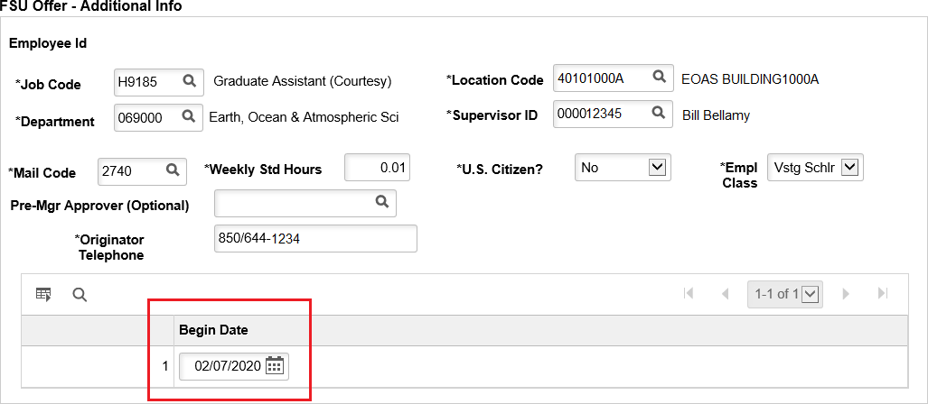
STEP 23: The Pre-Mgr Approver field is optional. Use the lookup button to search and select a Pre- Mgr Approver, if desired. The Originator Telephone will automatically populate.

STEP 24: Enter the Begin Date.

Note: The Begin Date typically matches the start date on the DS2019, however, Visiting Scholars are permitted to start 30 days prior to the J-1 start date.

STEP 25: Save the Job Offer by clicking the Save as a Draft button. This will allow you to attach approval documents.

STEP 26: Click the Edit Offer button. Attach the approved Visiting Scholar Export Control to the job offer.
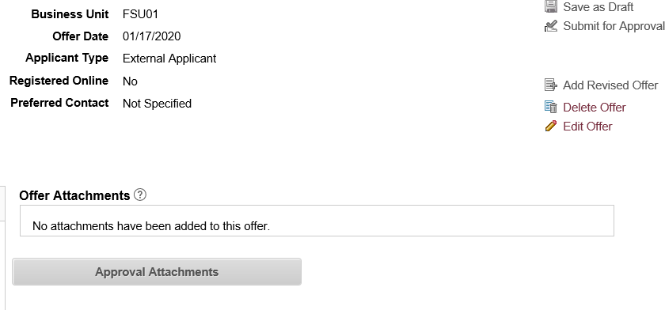

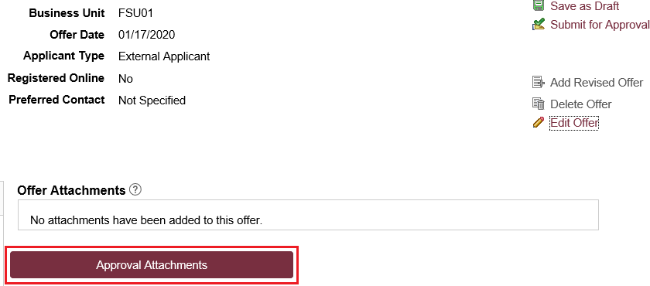
Step 27: Attach the approved Export Control Document by clicking the Approval Attachments button and uploading the document.

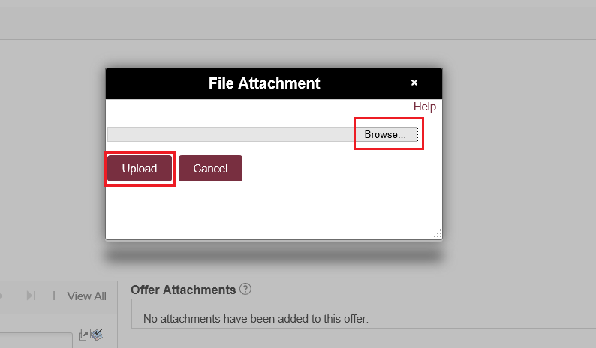

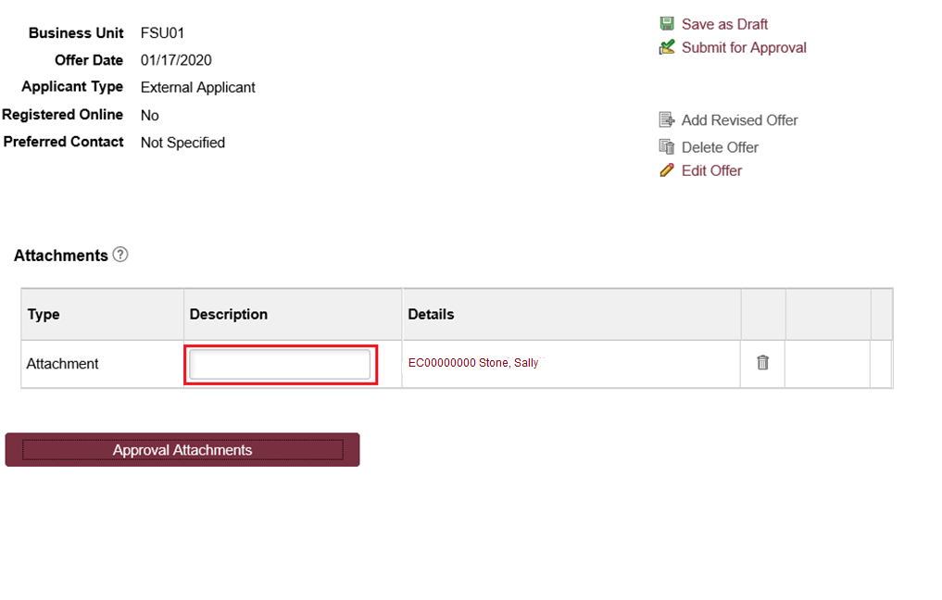
Step 28: Insert a description of the Document.

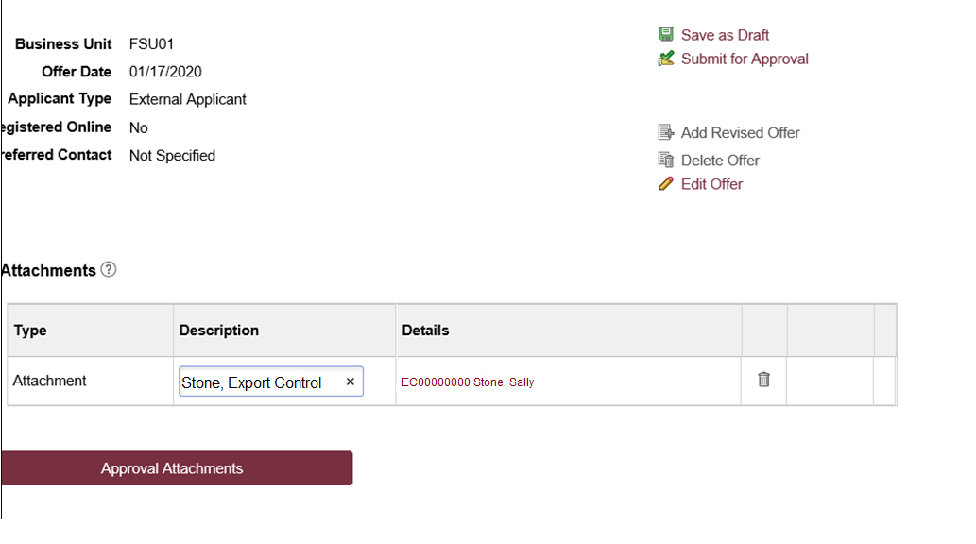

NOTE: The completed and signed Visiting Scholar Agreement and Foreign Government Talent Recruitment Program Form (FGTRP) will be required for processing. Please upload this document into the supplemental documents step in Onboarding if it was not uploaded into the Export Control Process in RAMP.

STEP 29: Click the Background Check tab.
Enter a Description of Duties for the appointment.
Confirm the Budget Manager and Budget Manager Email is correct.

Enter or look up a valid Purchase Order # or enter a valid Foundation Fund # to pay for the background check. The Line # will generate based on purchase order selected.

NOTE: The department will only be charged if a background check is required.

STEP 30: Answer each question on the Background Check Questionnaire; No or Yes as applicable. Confirm these answers with the hiring supervisor.

Once the questions are answered, the background level will generate at the bottom of the questionnaire.

The background check level will be reviewed by Human Resources Background Check staff.
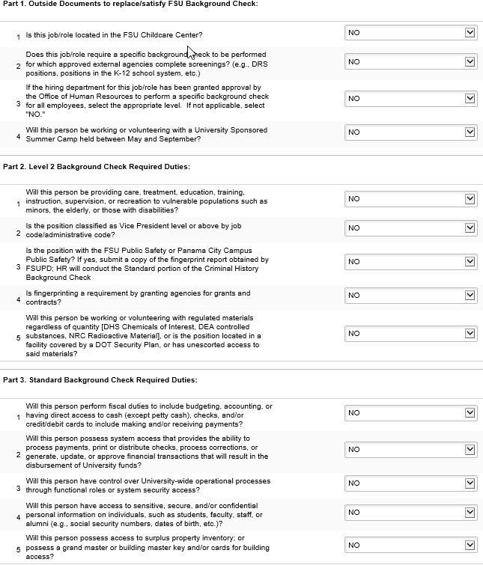

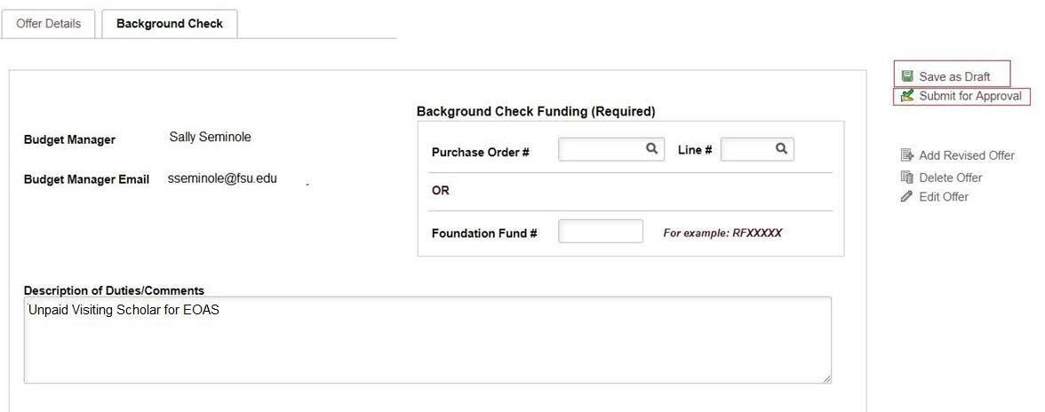

STEP 31: Submit for Approval
After you’ve submitted the job offer, a confirmation message pops up. Click the OK button.

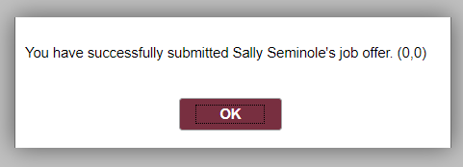

STEP 32: Navigate to the Approvals tab to review the status of the job offer in the workflow.

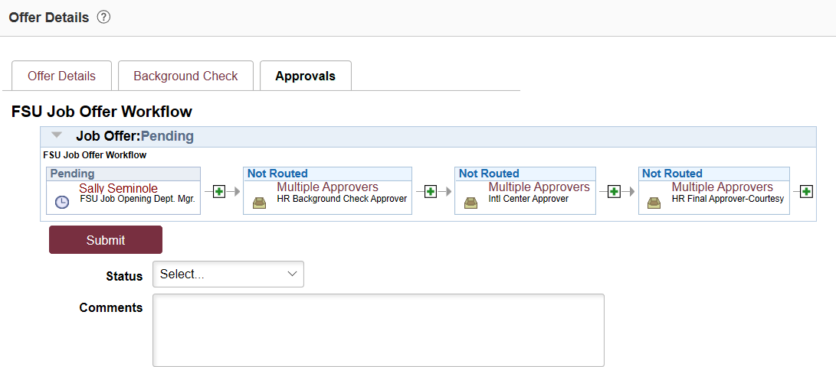
NOTE: Once the job offer is fully approved, Human Resources will launch the Smart Onboarding invitation to the candidate and the department will receive an email.
Any visiting scholars that require a J-1 visa will route automatically through the Center for Global Engagement.

To check the job offer status in workflow, navigate to the job opening through Recruiting > Search Job Openings > across from the candidate’s name, click Other Actions > Recruiting Actions > Prepare/View Job Offer > Approvals tab.

Questions
- For general questions about this procedure, email hr-courtesydocs@fsu.edu.
- For RAMP questions, contact Diana Key at dkey@fsu.edu.
- For Visiting Scholar questions, contact Stephen McDowell at steve.mcdowell@cci.fsu.edu.
- For questions regarding the J-1 process or non-resident alien visas, email cge@fsu.edu.

